**APPLIED PHYSICS LAB ASSIGNMENT NO. 4**

Name: “Muhammad Junaid Nazir”

Roll No.: “200828”

Department: “Computer Science (B S)”

Section: “B”

**Determinition of Friction Coefficient**

Apparatus:

* A wooden block.
* Inclined surfaces (smooth , wooden , rough).
* Meter rod.

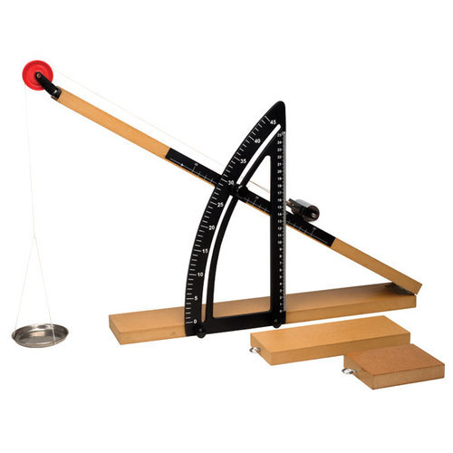

Procedure:

1. Measure the mass of wooden block by using balance.
2. Place the wooden block at moveable end of any of the surfaces.
3. Raise the surface plane slowly until the wooden block starts moving.
4. Lock the plane and measure the angle of the inclined plane using the attached protector.
5. Measure the y-axis distance between starting point of wooden block to the surface by using meter rod.
6. Measure the x-axis distance that is projection of displacement of block.
7. Calculate coefficient of friction by using appropriate formula.
8. Repeat the steps fot other surfaces.

Observations:

|  |  |  |  |  |  |  |  |
| --- | --- | --- | --- | --- | --- | --- | --- |
| Sr. No. | Material | Surface | Horizontal distance x  (m) | Vertical Distance y  (m) | Calculated  Θ  (tan-1 y/x) | Observed  θ | Friction coeficient  µs |
| 1 | Wooden block of 125.66 g | Smooth | 0.724 | 0.406 | 29.3° | 24.8° | 0.56 |
| 2 | Rough | 0.521 | 0.638 | 50.8° | 44.3° | 1.22 |
| 3 | Wooden | 0.762 | 0.345 | 24.4° | 22° | 0.45 |
| 4 | Wooden block of 150 g | Smooth | 0.821 | 0.358 | 23.3° | 21.6° | 0.43 |
| 5 | Rough | 0.629 | 0.589 | 43.2° | 38.5° | 0.94 |
| 6 | Wooden | 0.835 | 0.301 | 20° | 17.9° | 0.36 |

Calculations:

**For first mass (125.66 g)**

Smooth Surface

µs = y/x = 0.406 / 0.724

µs = 0.56

θ = tan-1 y/x = 29.3°

Rough Surface

µs = y/x = 0.638 / 0.521

µs = 1.22

θ = tan-1 y/x = 50.8°

Wooden Surface

µs = y/x = 0.345 / 0.762

µs = 0.45

θ = tan-1 y/x = 24.4°

**For second mass (150 g)**

Smooth Surface

µs = y/x = 0.358 / 0.821

µs = 0.43

θ = tan-1 y/x = 23.3°

Rough Surface

µs = y/x = 0.589 / 0.629

µs = 0.94

θ = tan-1 y/x = 43.2°

Wooden Surface

µs = y/x = 0.301 / 0.835

µs = 0.36

θ = tan-1 y/x = 20°